**INTRODUCTION TO JAVASCRIPT**

1. Prompt for amount, interest rate and no. of years and calculate simple interest.

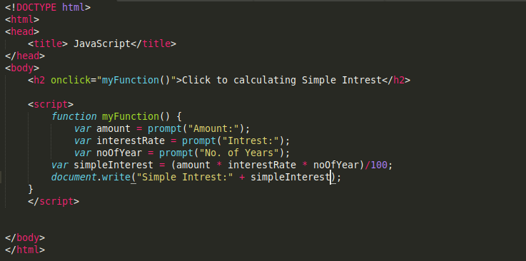

Output:



1. is palindrome string

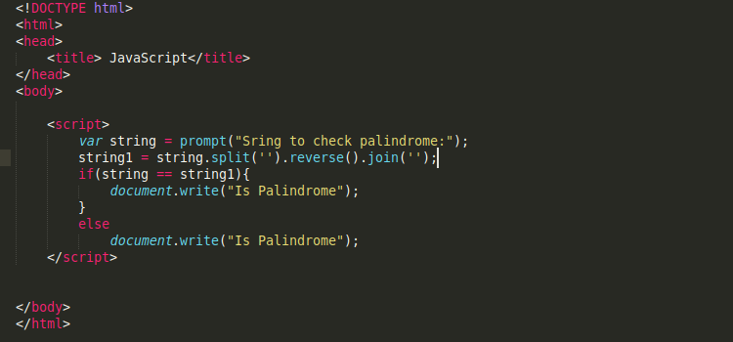

1. Area of circle

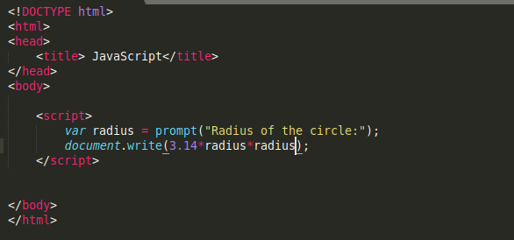

1. Copy information of one object to another and log it to console.

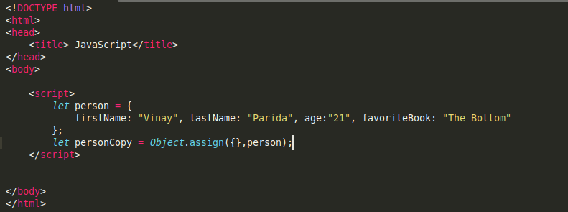

Output:

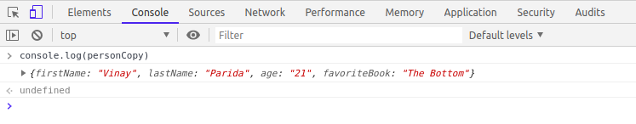

1. create a list of objects of Employee with info as follow :
   * Name, age, salary ,DOB

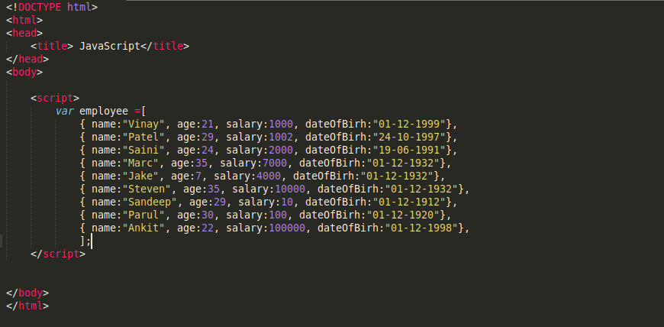

* + filter all employees with salary greater than 5000

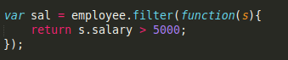

Output:

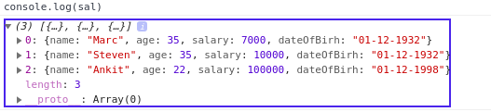

* + group employee on the basis of their age

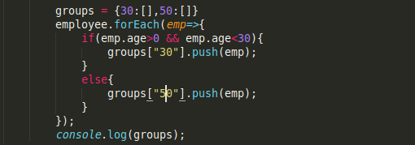

Output:

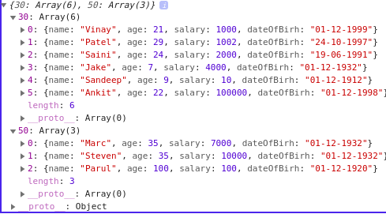

* + fetch employees with salary less than 1000 and age greater than 20. Then give them an increment 5 times their salary.



Output:

